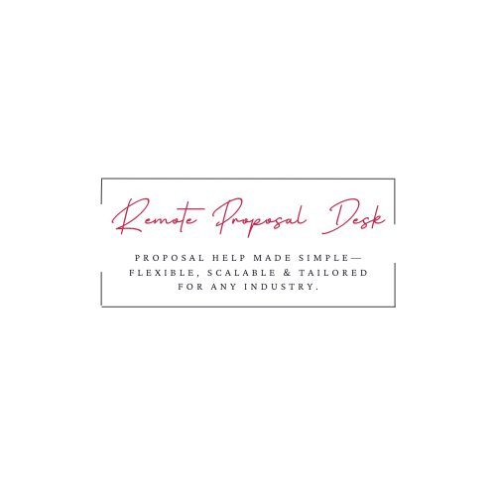
Proposal Coordinator Checklist
Remote Proposal Desk | www.remoteproposaldesk.com

Client |  |  | RFP Name/No.
RFP/RFI Link |  |  | Solution Proposed
Questions Due |  | Edit/DP Date
Production Date |  |  | Proposal Due
Proposal Team
Activity/Task |  |  |  | Assigned To |  | Date Due/Complete | Done
- Read & analyze RFP (identify gaps in services, red flags/concerns, threats, opportunities, questions, etc.) |  |  |  |  |  |  | ☐
- Create a collaboration site |  |  |  |  |  |  | ☐
- Identify/request SMEs/team members/resources |  |  |  |  |  |  | ☐
- Confirm teaming partners/subs |  |  |  |  |  |  | ☐
- Create project plan (outline of tasks and deadlines to get the proposal completed and submitted) |  |  |  |  |  |  | ☐
- Create proposal shell (copy & paste questions, requirements, RFP instructions, evaluation criteria, etc. into template) |  |  |  |  |  |  | ☐
- Populate the proposal template with standard content, past responses, etc. |  |  |  |  |  |  | ☐
- Schedule the kick-off call (invite everyone working on the proposal) |  |  |  |  |  |  | ☐
- Create submittal instructions |  |  |  |  |  |  | ☐
- Request Compliance & Contract review/Surety, etc. |  |  |  |  |  |  | ☐
- Request references and past performance |  |  |  |  |  |  | ☐
- Request production (if needed) |  |  |  |  |  |  | ☐
- Submit Intent to Bid |  |  |  |  |  |  | ☐
- Compile & submit clarification questions to client/attend pre-bid conference |  |  |  |  |  |  | ☐
- Send the Agenda and writer’s package to the team before the Kick-off Meeting |  |  |  |  |  |  | ☐
- Conduct a kick-off meeting |  |  |  |  |  |  | ☐
- Check for Addendums |  |  |  |  |  |  | ☐
- Develop new content (engage SMEs to help create content) |  |  |  |  |  |  | ☐
- Send a reminder that the edits are due |  |  |  |  |  |  | ☐
- Customize content for the specific client |  |  |  |  |  |  | ☐
- Send first draft to the team to review/edit |  |  |  |  |  |  | ☐
- Check for newly released Addendums |  |  |  |  |  |  | ☐
- Review the compliance matrix to ensure proposal requirements are being met |  |  |  |  |  |  | ☐
- Review project plan and update/modify (be sure to share changes with the team) |  |  |  |  |  |  | ☐
- Compile all input/edits |  |  |  |  |  |  | ☐
- Send second draft to team for review |  |  |  |  |  |  | ☐
- Check for Addendums |  |  |  |  |  |  | ☐
- Final edits (incorporate final edits into the master proposal document) |  |  |  |  |  |  | ☐
- Quality check – formatting (ensure document is correctly formatted – i.e., page numbers, attachment numbers, styles, placement of graphics, pagination, etc.) |  |  |  |  |  |  | ☐
- Quality check – content (final read through for flow, grammatical/spelling, and messaging). |  |  |  |  |  |  | ☐
- Final sign-off (Subject Line: FINAL REVIEW – DEADLINE! First line, let her know it’s the final review) |  |  |  |  |  |  | ☐
- Production/Ship/Hand Deliver/Email |  |  |  |  |  |  | ☐
- Confirm delivery |  |  |  |  |  |  | ☐
- Archive (include final proposal, pricing, references, past performance, SOW, etc.) |  |  |  |  |  |  | ☐

